**Reminder 1 - Pending Acceptance_Offer_’Candidate Name’**

" This is a system generated message and please do not respond to this email."

Dear Candidate Name

Greetings for the day!

This is with reference to the Offer from TASC Group with our client ‘Client Name’

We have not received your acceptance on the above mentioned offer letter. Request you to confirm on your acceptance by tomorrow for us to initiate the rest of the onboarding process.

Please respond to the initial Offer Letter email on your response and for any queries on your offer letter. If you have already accepted the Offer Letter then please ignore this auto alert.

Best Regards

TASC Group Joining Team

Talk to us @ 800 - ECARE (32273), Sunday to Thursday 8AM to 5:30 PM

Note:- If you have already shared the offer acceptance during the weekend please ignore this email, as we will update our system during working days.

Exec Tasc_Offer4days_Mail_sp '2'

Exec Tasc_Offer2days_Mail_sp '2'

**Residency Visa approval Completed _ Associate Name_ Client Name_ Associate ID**

Dear ‘Associate Name’,

Congratulations! Your Residence Visa has been approved, and the process has been successfully completed.

Please note that it is no longer necessary to provide your original passport to complete the Visa stamping process. You will receive a notification once your e-Visa stamping is completed, after which you can easily download your stamped e-Visa via the UAE ICP app.

1. **How to Download e-Residence and Emirates ID Copies from the ICP App:**
2. Download ICP mobile application (Available in [Play Store](https://play.google.com/store/apps/details?id=com.echannels.moismartservices&hl=en&gl=US) and [Apple Store](https://apps.apple.com/ae/app/uaeicp/id1374301965))
3. Login using your Emirates ID number
4. Download the e-Residence copy and Emirates ID copy

**How to collect your Emirates ID card:**

After your Emirates ID card is printed, the UAE Authority will send you a notification via SMS to your registered mobile number. Once you receive this message, there are two options available for collecting your Emirates ID card.

1. Direct to Your Location: You can choose the option to have the Emirates ID sent to your location. Once you receive the Emirates ID Card, we request you to share a scanned copy of the card, both the front and back sides, with us at [documents@tascoutsourcing.com](mailto:documents@tascoutsourcing.com)
2. Through TASC: Please share the SMS you receive from the UAE Authority with us at joiningauh@tascoutsourcing.com, so our PRO can collect your Emirates ID from the centre. You can then collect the Emirates ID from the TASC Office.

If you have any further questions, please do not hesitate to reach out to us.

We value your feedback, so please share your thoughts with us via our feedback survey at [letstalk@tascoutsourcing.com](mailto:letstalk@tascoutsourcing.com) or call 800-ECARE (80032273) from Monday to Friday, 8:00 am to 5:30 pm.

Regards,

TASC Team

**MOL Approval Received ‘Candidate Name ‘ _Client Name ‘ _ ‘Staff ID**

Dear ‘Associate Name’

Congratulations! We have received your MOHRE(Ministry of Human resource) approval for employment with TASC Group.

Here are the key milestones of your onboarding process at TASC Group:

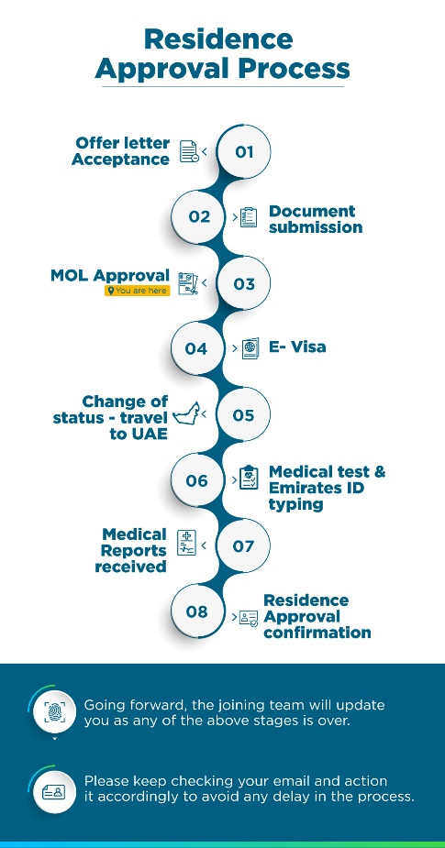

Should you have any further questions, please do not hesitate to raise a ticket on our Chat bot – AIDA +97143588500 or write to us at [joining@tascoutsourcing.com](mailto:joining@tascoutsourcing.com)

We will be available during the weekdays, Monday to Friday, from 8:00 am to 5:30 pm.

Kind regards,

# Joining team

# TASC Group